Does the number of children affect parents’ happiness?

Bethany Perry
SOC 625
Advanced Research Methods

April 25, 2024

Introduction
A lot of couples who are thinking about having children may wonder if it is the right decision for them. While the research is split between remaining childless and having children, the big question is, “Will I be happy with my decision?” While no one can say for certain there is research to help answer this question. In an article by the Population Council the authors say, “Parenthood changes lives in both positive and negative way, many of them unexpected by the parents themselves” (Margolis, 2011). Becoming a parent is a significant personal decision and unfortunately there is no way to know if it will fulfill you until you are in the thick of it. However, some background and research does tend to guide deciding couples and individuals in their decision. Are people who wait longer to have children happier? What about people with just one child, or people who have 3 or more children? Are people with more education likely to be happier with or without children? No matter what the research says, people deciding to have children need to decide what’s best for them.
In The Journal of Marriage and Family the author says, “To understand the psychological consequences of parenthood, however, it is important to recognize not only the burdensome aspects but also the beneficial aspects thereof and to grasp the ways in which they offset each other” (Pollman-Schult, 2014). Being a parent is incredibly complicated and it can be difficult to know if you are successful for 18-25 years. While a lot of research has been done on the cost of children there is significantly less on the joy that children can bring to your life. Most research focuses on the infant and toddler stage of research not much is done as the children grow and parents become more experienced. What about people who are out of the decision-making phase and have chosen to be done having children? Do those people tend to be happier than those just starting their parenthood journey? To better understand these questions, we need to discover how more education effects the number of children people have.
With so many young people these days deciding not to have children due to the financial burden it would cause within their lives it is important to see the positive impact that children have on their parents and how that can affect parents psychologically. Society would benefit from learning more about how people change after becoming parents. Once society learns the pros and cons not only about the timing of children but also when parents are the happiest, we can create more parental support during times of need. Communities and social programs can become more adaptive to help parents during their most struggled phases of parenthood.
Some may wonder why we want to know this information or its relevance in society. Being able to help parents make informed decisions about education, having one or more children can give confidence back to parents. There are many phases to the parenting journey, but research tends to focus mainly on when the children are infants to preschool aged. One question that can help in the decision to have more children is, are people who no longer expect to have children happier than those who are still having children? An article from the Interdisciplinary Journal of Applied Family Studies says that “Those in the childbearing or career building years, for example, are assumed to experience greater role demands than those in the launching or empty nest period of family life, which can strain intimate relationships” (Mitchell, 2010). The journey of parenthood can have so many ups and down that potential parents may wonder how do I know what the right number of children is? Is having a larger family with 3-4 children right for me? Or should I have a smaller family with 2 or less children? And while this is deeply personal decision between partners the research will bring us clearer answers on how current parents of various family sizes feel. With the current cost of living so high some may wonder how to support a larger family? Are people with bachelor’s degrees more likely to have less children than people with a high school diploma? If so, why do we think that is? Could it possibly be because they tend to meet their partners later in life? Are they more career focused? Are they more educated on the lifelong cost of children and are being more cautious? All of these are questions that can help us better understand how society operates and what drives the decisions of young adults and new parents.
As a mom of four children, I felt this research topic would be interesting to learn more about. I am a college graduate, and my husband has a high school diploma which is something I assume the research does not take into consideration is partners who have different levels of education. This is why I will consistently state that the decision to have none, one or more children is very personal and something that no amount of research can answer for you. I am excited to share what the articles and the statistics will bring to light throughout the duration of this paper.

Article Summaries
Article 1
In the article A Global Perspective on Happiness and Fertility by Rachel Margolis and Mikko Myrskylä dive into the complex dynamics around happiness and fertility, reflecting on cultural norms, societal contexts, and individual experiences. Parenthood grants both good and bad changes into individuals' or couples’ lives, but the depth of its impact varies greatly based on gender, marital status, and life stage (Margolis & Myrskylä, 2011). The connection between happiness and fertility changes based on many factors like age, income status, and a country's welfare or support. These aspects highlight the necessity for a deep understanding across different circumstances. By using the respondent’s demographic and other relative information, the study exposes noteworthy cross-national inequalities in happiness levels and fertility rates, casting light on the complex relationship between these variables (Margolis & Myrskylä, 2011).
The outcome of these findings ranges outside academic dialogues, offering respected material for corporations and governments alike (Margolis & Myrskylä, 2011). Their research highlights the significance of the complex relationship between happiness and fertility, with extensive explanations for social development and creativities aimed at cultivating family well-being. The deductions from the regression analyses reveal interesting patterns in the happiness-fertility relationship. Mainly while individuals with a reasonable number of children tend to report greater happiness, this correlation wavers with different demographic factors and age groups (Margolis & Myrskylä, 2011). For example, younger individuals may decline in happiness with more children, while older age groups display shaky tendencies, with three children often associating with higher happiness levels. The study dives into some thought-provoking material on dynamics such as income, health, and welfare systems further control this relationship, stressing the complexity of the subtleties at play. The result that, “At parity four and above, there is no statistically significant difference in reported happiness from those with no children” (Margolis & Myrskylä, 2011). Being a mom of four kids I think it is interesting to hear all the statistics and compare my personal experiences to the whole.

Article 2
In the article Parenthood and Life Satisfaction: Why don’t children make people happy? Matthias Pollmann-Schult discusses the stability of happiness that children can bring against the negative effects of raising children. Pollmann investigates the cost of having children and the toll they can take on your happiness. The primary study groups are from the United States and Germany to establish differences in culture, socioeconomic support, and the cultural norm to have children (Pollmann-Schult, 2014). They study the number of children, the age of children, marital status, and parental employment arrangements.
What is interesting is after the cost of a child is removed from the analysis children positively affect life- satisfaction, that is, until you reach the marital status dynamic. Single parents are significantly less satisfied than those in healthy relationships. This is because the phycological and financial pressure are deeper than those with partners (Pollmann-Schult, 2014). Even though mothers who choose to stay at home are more psychologically stressed they are happier than mothers who are in a single income home (Pollmann-Schult, 2014). This could be because single mothers are carrying the role of provider and mother, so they never get a break but stay at home mothers feel “role trapped” according to Pollmann.
Another aspect of the study looked at how many minor children were at home and how that affected the life satisfaction of parents. “After inclusion of equivalent household income in the model, all coefficients for number of children increased substantially in size and became statistically significant, indicating that the positive effects of parenthood on life satisfaction are suppressed by the economic burden associated with parenthood. The results, however, showed that the transition to a second or third child has no effect on the level of life satisfaction” (Pollmann-Schult, 2014). Pollmann also states that, “parental well-being is strongly contingent on the financial costs of parenthood, a factor that has been widely neglected in previous studies” (Pollmann-Schult 2014). This tells me that especially in the United States that parents need more support financially with their children. Overall parents are satisfied and happy with their decisions to have children, but I believe that we have gone away from the village mentality which can make parenting more psychologically stressful especially with elementary aged children.

Article 3
In the article Happiness in Midlife Parental Roles: A Contextual Mixed Methods Analysis by Barbra Mitchell her main point is that the role of parentings has changed so much over the course of history. Now parents are living longer with less children to care for, but those children are staying at home longer than in the past (Mitchell, 2010). She argues that despite these changes, being a parent is still highly valued and a status symbol is modern society, even above marriage and career achievements (Mitchell, 2010). Research shows that the more satisfied parents are in their roles the better the well-being of the family. Most of this research is done on parents of minors and excludes parents of young adults who may or may not still live home. The support that different cultures offer to parents also plays a significant role on happiness and parental expectations (Mitchell, 2010).
This study dives into midlife parenting and satisfaction as the children age. It looks at mixed methods such as intergenerational factors, income, and culture. The study observes context, time and meaningful influence in child development and family life dynamics (Mitchell, 2010). All the above elements shape how satisfied parents are in their role and their lives, but the study takes age, religion, marital status, education, and parents’ careers into consideration. The parent-child relationship, if it is healthy is a bond that is unbreakable impacting the well-being of both parties.
The research examined parental role happiness among 490 midlife parents from four Canadian cultural groups: British, Chinese, Indo/East Indian, and southern European. Results indicate that most parents have happiness in their roles, with contentment in their financial situation, retirement, emotional attachment to their child, good health, and younger age being associated with higher levels of happiness (Mitchell, 2010). Further investigation of these findings highlights the value of children meeting milestones and joining parents' values for increased parental happiness (Mitchell, 2010). The study suggested community resources and programs aiming to midlife and older adults were also provided. Overall, the study emphasizes the need for further research on parent experiences, specifically in the context of population aging, economic insecurity, and changing immigration patterns which is all more relevant now than when this article was first published.

Article 4
In the article, When and how does the number of children affect marital satisfaction? The researchers Kowal, Groyecka-Bernard, Kochan-Wojcik and Sorokowski look at the connection between marital satisfaction and the number of children a couple has in the article. As parents have more children, they have less time to invest in each other as there is increased care tasks, financial and physiological responsibility. Even if partners are fulfilled in their parental role, the stress of the role may take a toll on the marital relationship (Kowal et al., 2021). The study found that parents had peak happiness with their first child and subsequent children either caused happiness to stay the same or decrease over time (Kowal et al., 2021).

Based on the global research presented the number of children can negatively relate to marital satisfaction. Though what that number of children is can vary greatly depending on the country the respondent is from (Kowal et al., 2021). Although, women are typically more unsatisfied than men with increased children, because in most cultures many parental duties fall on the mother (Kowal et al., 2021). Fathers typically are the ones that are having fun with the children and experience less stress related to parental tasks. The research though leaves a lot of questions about the details of happiness and can lead us to do more in depth studies in the future.

“Moreover, as much greater share of variance can be attributed to individuals than to countries, one can reasonably conclude that marital satisfaction depends more on the individual characteristics than on the values promoted in the country” (Kowal et al., 2021). I truly believe this statement can be concluded without any research. Children can make or break a marriage and that depends on the individuals in the relationship. It could be one child or 8 children there is no guarantee of how the result of having a raising a child will impact your marriage until you are in the actual situation.

Methodology
The data for the hypothesis in this research was collected from the GSS (General Social Survey) Website which is a data exploration website from the University of Chicago. The research has been collected since 1972 and monitors change and studies American Society (GSS Data Explorer | NORC at the University of Chicago, 2018). The data is mostly collected in face-to-face interviews however beginning in 2002 they implemented computer interviews as well (GSS Data Explorer | NORC at the University of Chicago, 2018). The GSS is currently administered on even years to around 1500 respondents however, some years have had over samples (GSS Data Explorer | NORC at the University of Chicago, 2018).
I was able to use, “The GSS Data Explorer search function which covers both mnemonics and question text for each variable in the cross-section data” (GSS Data Explorer | NORC at the University of Chicago, 2018). This allowed me to find specific questions about the hypothesis and run the reports to find the data in this research. Once I was on the GSS website I identified my independent and dependent variables. The independent variables belong in the columns and the dependent are in rows. Once the information was inserted for each hypothesis, I ran the graphs and was presented with the statistics for the theories. The independent variables I used are CHILDS, DEGREE and CHLDMORE these went into the column section of my searches. The dependent variables are HAPPY and CHILDS these go into the row sections to form the cross tables. I used the Summary Statistics along with the graphs to complete my research and compare the information to the hypothesis.

Data Analysis
Research Question 1: Are people with 0-2 children happier than those with 3-4 children?
Theory: People with fewer children will be happier than those with three or more children. This is because they have more time to dedicate to each child. Parents would also have more income to spend on their children instead of having to divide between several children. The cost of living for 1-2 children is significantly lower than those with 3+ children.
Hypothesis: People with 1-2 children are happier than those with 3-4 children.
Independent variable in the columns (CHILDS)
Dependent variable in the rows (HAPPY)
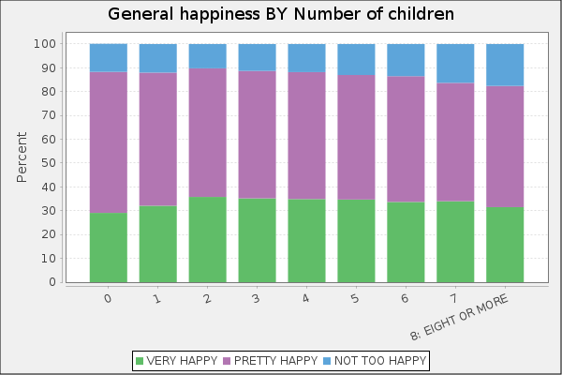
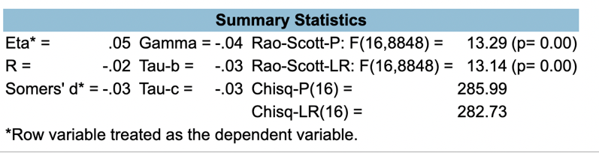
Analysis of variables listed above.
The above graph is showing the number of children a respondent has along the X axis and the reported level of happiness on the Y axis. The green section represents people who say they are very happy. This percentage seems to be between 29-35% regardless of how many children people have. The purple section is people who responded they are happy, and the blue is people who are not too happy. The distribution chart shows that respondents with 8 or more children are report being “Not too happy” more than any other group. The analysis weakly supports the theory the people with 0-2 children are happier than those with 3 or more children. Being “not too happy” and “very happy” increase or remains consistent with those who have less than 8 children. The highest group that is “Very Happy” has two children while the largest group of respondents that are “pretty happy” is those who have no children. The statistics significance from this graph is 0.00 which is less than alpha consequently you can be 99% confident that a relationship exists between these two variables and that we must accept this hypothesis.

Research Question 2: Are people with bachelor’s degrees more likely to have less children than people with a high school diploma?
Theory: People who have bachelor’s degrees have less children than those with a high school diploma. People who have bachelor’s degrees may have a better understanding of the lifelong cost and emotional impact of having children. People who have higher education tend to be childfree during this time and may choose not to have children until their studies are complete. Respondents may have more mindfulness because they are older, and their own brains and bodies would have had more time to mature. For people who have not chosen to have higher education, they may have found a partner sooner in life and had more time to have children without the risk of age and medical complications.
Hypothesis: People with bachelor’s degrees have less children than those with high school diplomas.
Independent variables are in the columns (DEGREE)
Dependent variables are in the rows (CHILDS)
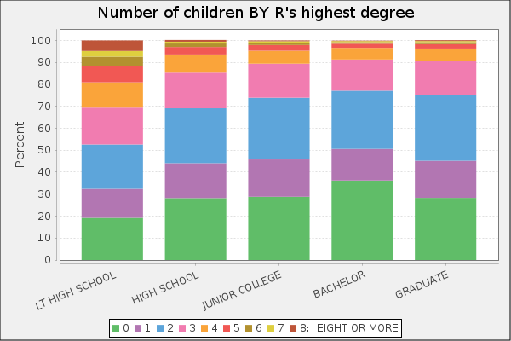
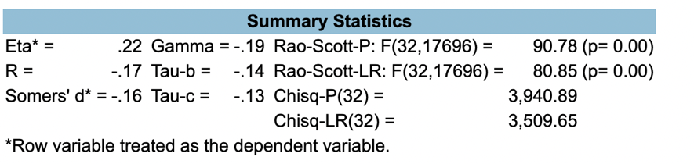

Analysis of variables listed above.
The graph above is show the level of education completed along the X axis and the number of children along the Y axis. The green section represents people with 0 children, with the highest percentage being about 35% with a bachelor’s degree. People with a high school or lower education level have the highest percentage of 3 or more children. People with a graduate level education tend to have more children than those with junior college or bachelor’s degrees. Regardless of the education level 2 children is the most popular number of children to have. The data does support the hypothesis that people with higher education tend to have less children than those with a high school or lower education. The statistics significance from this graph is 0.00 which is less than alpha consequently you can be 99% confident that a relationship exists between these two variables and that we must accept this hypothesis.

Research Question 3: Are people who no longer expect to have children happier than those still expecting to have children?
Theory: People who are no longer expecting to have children are happier than those who are still expecting children. This is because having small children and pregnancy is such a stressful time in life for both men and women. Also making the decision to be done with children can be very stressful for both parents and having this discussion with your significant other can cause more stress on the relationship, leading to unhappiness.
Hypothesis: People who are no longer expecting to have kids are happier than those still expecting to have children.
Independent variables are in the columns (CHLDMORE)
Dependent variables are in the rows (HAPPY) 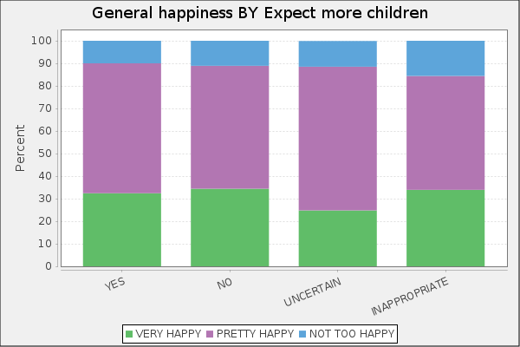
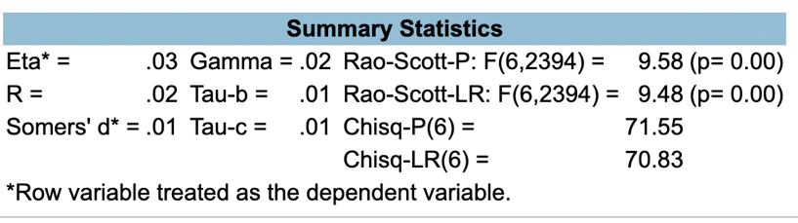
Analysis of variables listed above.
The graph above is showing if respondents expect to have more children along the X axis and their reported happiness on the Y axis. The green and purple column shows that people who are generally happy weather they have decided they want more kids, are done or they are unsure. This does not support the hypothesis above that people who are still expecting to have children are less happy than those who are done having children. It would also appear that the people who found this question inappropriate are the least happy group. The statistics significance from this graph is 0.00 which is less than alpha consequently you can be 99% confident that a relationship exists between these two variables and that we must accept this hypothesis.

Conclusion
To close the research covers the intricacies of parenthood and the facets that impact parental happiness and decision-making. An important part of this research is evaluating the timing of when people decide to become a parent, the number of children people have, and the level of education received. This research is valuable to gain a deeper knowledge of how these factors with individuals and society. We will be able to finally have debates on family planning and parental well-being in all stages of parenthood.
The decision to become a parent is a very personal and jam-packed with hesitations and complications and happiness. While research proposes insights into the numerous factors that impact parental happiness, it cannot absolutely predict specific outcomes. Parenthood carries both delight and trials, and its bearing spreads beyond financial concerns. As society wrestles with developing family systems and priorities, understanding the inner workings of parenthood becomes more critical. As we investigate deeper into how parents make the decisions for each chapter of growing children, we can better support individuals in making educated decisions about their family planning and offer valuable support during their parenting journey.
The articles did back up the research that, “…happiness declines with the number of children so that those with no children or only one child is happiest, and those with three or more children are least happy” (Margolis & Myrskylä, 2011). While all the articles were consistent, they concisely report that there are many factors that can affect the happiness in parents and that no one factor can predict happiness in a parenting journey. The positive relationships within the data and research articles are consistent but not extreme. As the graphs showed there were no big jumps from people who did not have children to those who had 4+ children. There was not perfect number of children to peak happiness ratio. Maybe people with fewer children are slightly happier but as the number of children increased happiness stayed about the same.
This research could help society see that there is still room for improvement in parental happiness. If society had more programs to support parents as they adjust to more children or aging children, we may see an increase in happiness overall. This could help start some good conversations about what we as a county can do to support parents who are raising the next group of leaders. With more research there could be more support for working parents like income-controlled daycare costs. Another benefit would be free or reduced education costs for parents to grow their careers and be better able to provide for their families.
At the conclusion of this research, questions remained that would require more extensive research. How are partners classified if they do not have equal education levels? What about parents, like me who go on to get their graduate degrees after having children? Should they be part of a different study? It would be interesting to see how many parents go on to get higher education once they are out of the young children stage. Does this lead to increased happiness as the parents find themselves again? All the questions would make for excellent research topics in the future. They would also help to fund support from social programs to encourage parents to go back to school and receive higher education.

References
Margolis, R., & Myrskylä, M. (2011). A global perspective on happiness and fertility. Population and Development Review, 37(1), 29–56. https://doi.org/10.1111/j.1728-4457.2011.00389.x
‌
Pollmann-Schult, M. (2014). Parenthood and life satisfaction: Why don’t children make people happy? [Review of Parenthood and Life Satisfaction: Why Don’t Children Make People Happy?]. Journal of Marriage and Family, 319.
‌
Mitchell, B. A. (2010). Happiness in midlife parental roles: A contextual mixed methods analysis. Family Relations, 59(3), 326–339. https://doi.org/10.1111/j.1741-3729.2010.00605.x
‌
Kowal, M., Groyecka-Bernard, A., Kochan-Wójcik, M., & Sorokowski, P. (2021). When and how does the number of children affect marital satisfaction? An international survey. PLOS ONE, 16(4), e0249516. https://doi.org/10.1371/journal.pone.0249516
‌
GSS Data Explorer | NORC at the University of Chicago. (2018). Norc.org.b https://gssdataexplorer.norc.org/
‌

