Retail Banking Concept Map
Bethany Perry

I have chosen to make a basic concept map of the retail banking branch. It may seem like these are not used very much anymore but some locations as still perform thousands of in person transactions per day. Everything that happens in the branch is meticulously controlled and has a plan for retention or destruction. Employees are carefully tasked with specific keys and codes to ensure that all items are dual controlled and that there is minimal risk for loss. Let’s look more at the map:
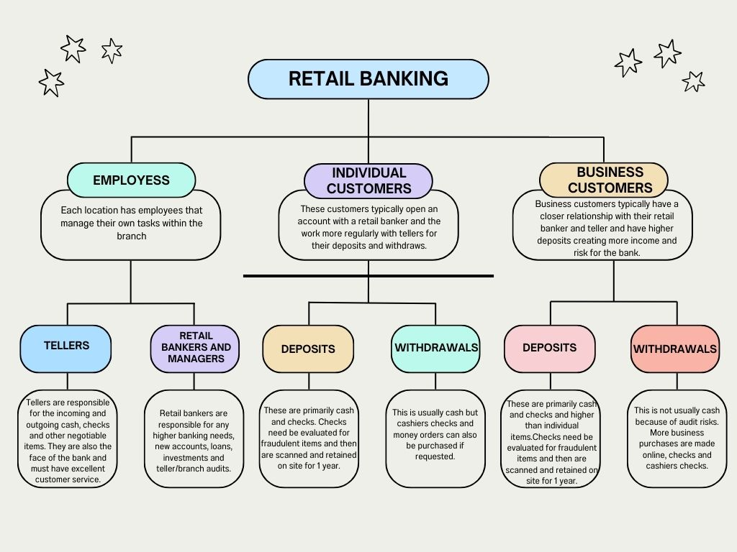

The retail banking system may seem simple from the outside. You go in make a deposit the bank has your cash or checks, and you leave. But what happens to all the cash deposited? What about the checks? Are they shredded or do they keep them somewhere? These are all great questions. Every retail branch has a vault that a maximum amount of money can be in. So, we hire contracting companies such as Loomis or Diebold to remove excess cash from the branch. At the same time sometimes, we need money because we are running low on certain denominations or coins. The same company would bring that money into us for storage in the vault.
There are several connections and crossovers within the map. Let’s start with the services offered by retail banking. Cash is the riskiest item on the map because it is the most valuable and has the highest demand. Contractors bring in cash to the branch that has been ordered and it is stored in the vault. This cash is then distributed to tellers as needed and kept under dual control while in the vault. Once the cash is in the possession of the teller it is then given out as requested to individual and businesses. This can be in the form of cashing checks, withdraws from an account, or exchanges currency for a different denomination. Every teller has a limit they must stay under and if this limit is exceeded the excess cash in their drawer is then sold back to the vault where is remains under dual control. Once the vault has reached its cash limit the contractors are then contacted to pick up the extra cash and it is brough back to the main branch location and either sent off to the federal reserve or held on site for other orders.
The next biggest connection on the concept map is checks for teller, contractors and clients including individuals and businesses. This is because, like cash, they encounter the most individuals. Checks are brought in for deposit or cashing by individuals or businesses. Checks have risk on their own, they can be fraudulent, unfunded, and take time for the customer to receive their funds. For these reasons checks are typically kept on site for 1 year and then in a retention area off site with our contractors for 7 years. Checks are brought in by businesses and customers alike and exchanged for cash or deposited into the clients checking account.
The boundaries of this map are significant. There are so many other operations that happen in the back offices that help the branch run effectively. However, adding all of those to this map would make it far more intricate and difficult to follow. This map shows just one of many teams that it takes for a branch to run successfully. There is more information that we could go into on retention, security, software, differences in tellers and retail bankers. All of which could have their own mapping system.
Some problems coming from this current structure are the risks that are involved with handling cash and checks. Having such a hands on approach leads to natural human error. This is one reason I have done research on moving to a fully automated system that is handled though face recognition software. Another issue that comes from the current system is that if something were to break down, such as the contractor that brings cash into the banks, then not only would the branch run out of cash, but customers would become increasingly dissatisfied with their service. Secondly, if we lose employees there are not enough people to service customers. Since every employee is assigned one side of the combinations to open vaults and other areas it could lead to a lack of someone being able to open the branch and its vaulted areas. This would also cause a huge gap in customer service.
One of Lewin’s practical theories says, “You can understand behavior only in relation to all forces acting on a person at a given moment.” (Weisbord 2011) Weisbord then translates this to a management theory that says, “To change a system, take into account economics and technology by involving all stakeholders.” (Weisbord 2014). I find this especially relevant in retail banking, if one procedure is changed or updated hundreds of people need to know about it immediately. The leaders in the financial industry need to consider every single person that any changes will touch. I think this is especially true for retail banking because it is typically considered the lowest job in the industry but almost every change made to compliance and retention affects these employees the most.
“McGregor’s prediction that an organization’s full human protentional would stand or fall on people’s ability to work in group’s, (John Paul Jones) set up a pioneer OD department.” (Weisbord 2011). At the time, in the early 60’s this was probably a big risk and not something a lot of companies were open to. Now you cannot find a large company without one of these departments. They are crucial to every company and should be the head of every concept map made about corporations. Without organizational development we would not have an effective way for departments to work with each other and reach our full human potential as McGregor put it.
The financial industry has a long way to go as far as technology is concerned. However, they have spent a lot of effort into being an effective organization. I personally have worked with 4 financial companies and been within various departments of them and each one has systems in place to ensure that all regulations are followed, and they are performing to the best of their ability.

References

Weisbord, M. R. (2011). Productive Workplaces. John Wiley & Sons.

This was my original map made in Concept Maps if you’d like it for reference.
